
Property Owners Association Board Meeting Minutes
7 p.m. January 26, 2026, at the Edwardsville Moose Lodge 7173 Marine Rd.

Call to order: Andrew Reznack, board president, called the meeting to order at 7:00 p.m.
Present: Board members- John Bode, Graham Johnson, Andy Leek, Mark Olson, Todd McClew, Robert Ribbing, Terry Reising, Andrew Reznack, Ben Richey, Joshua Schumacher, James Taylor, Richard Welle.
Absent: Frank Gremaud, Lori Scarlett, Roy Wehling – All excused
Support: Carolyn Green and Maureen Bode from C. Green & Associates, Inc.
Visitors: Alison Novasek, Paul Jenkins

VISITOR COMMENTS – none

MINUTES – Rick Welle made a motion to approve the minutes as corrected by Andrew Reznack. Graham Johnson seconded, and the motion passed unanimously.

FINANCIAL REPORT – Richard Welle, treasurer, went through the financial reports from CPM and the loan status. Graham Johnson made a motion to approve the December financials. Terry Reeising seconded, and the motion passed unanimously. Financial reports are available to all residents on the management company portal www.portal.cpmgateway.com.
Leins will be filed on the 8 properties that have not paid anything (if they haven’t already).

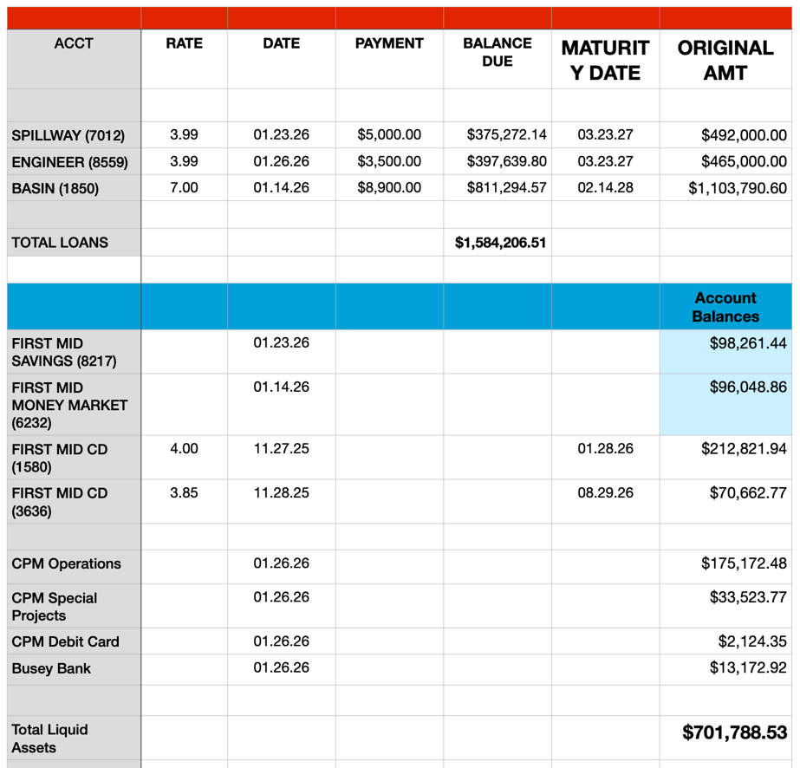
Rick Welle presented budget changes as requested by the committees. 186,983 (up around $5,000). Interest income down. Anything in surplus will help carry us over to new assessments and then can be moved into a CD for capital expenses or to go to paydown debt.

OLD BUSINESS – Annual corporate report went to Andrew.

REPORTS FROM THE STANDING COMMITTEES
Building and Architecture - Andy Leek and Terry Reising, co-chairs.
Need a request for permit with all changes clearly marked for 304 Barnett.

Common Areas – Ben Richey and Ryan Beevers, co-chairs
Trees removed at W6 along Franklin. There are some dead trees, but nothing looks concerning. Will not take mowing out to bid. Marinas have 3 open slots.

Dam Maintenance: Roy Wehling, chair.
Roy has cost estimates for spraying the dam. Tree removal and fence costs are in the budget.

Legal – Joshua Schumacher, chair.
Will look into the CPM contract. The current contract says it is good for another year.

Restrictions – Graham Johnson, chair.
City to put a speed limit monitor near 407 West Lake.

Safety - John Bode, chair.
Not a lot going on this time of year. Goal for 2026 is doing letters on boat ownership issues.

Silt & Erosion - James Taylor, chair.
Stutz gave the association an estimate for finishing the dredging at Cove A. They would put an excavator on a barge and take silt out from E8. They took mapping info and estimated 33,000 cu yards of material needs to be hauled away. $1,750,000.

At the last meeting Roy asked for the price for 5 piers no boardwalk instead of the current marina configuration. The cost is $23,400 per pier which is more than the current plans.

All the costs will be presented to the owners at the Annual Meeting to see if there’s any consensus on how to proceed. It was pointed out that the board was able to get buy-in from off lake residents by building marinas to give more access. Those options need to be presented as well.

The thought at this point is to focus first on priorities for places that can be reached when the lake is down and then Cove A. Rick Welle did not see financial capacity to do both projects. Jim Taylor and Rick Welle agreed to look into refinance options.

No new business or report from Fish & Wildlife, Meetings & Elections, or MPI committee.

Administrative Report: Submitted by Carolyn Green - Progress from the last two months was summarized in a written report. The board members did not have any questions.

Next Meeting: Hearing no new business, the meeting was adjourned. The next meeting will be the Annual Meeting 7 p.m. Monday, Feb. 23, 2026, at the Moose Lodge.

